Appendix 2 of Re-registration Application
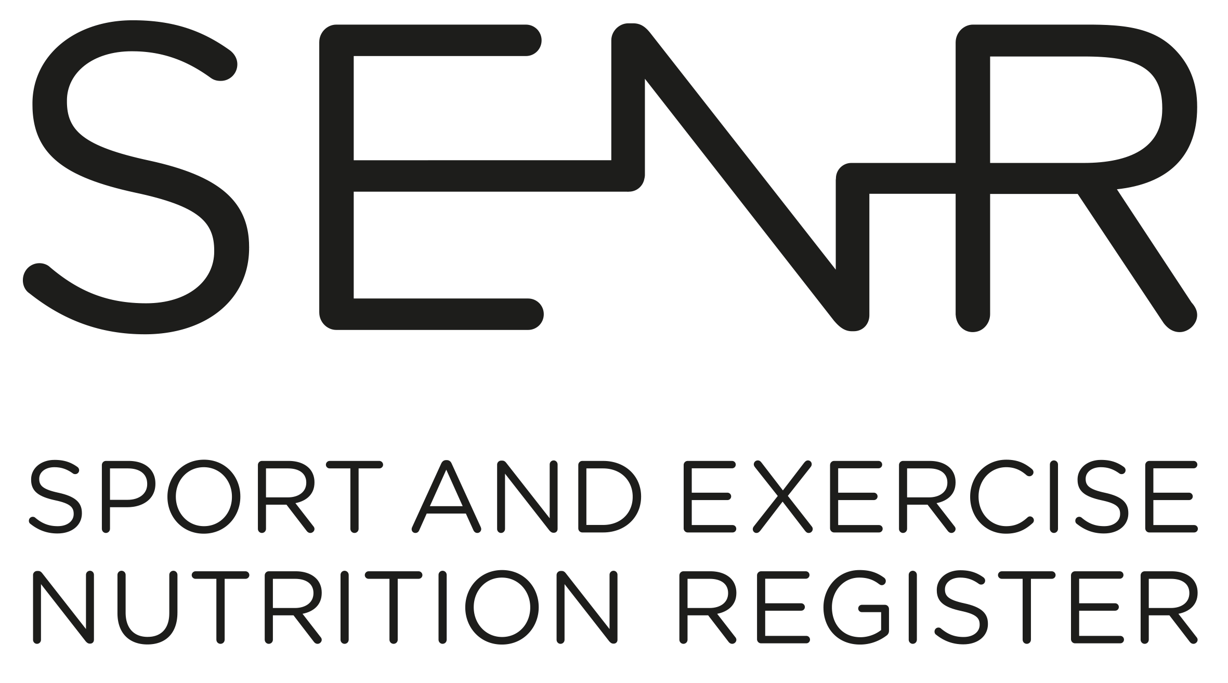
Personal Statement

Please complete your personal statement on this document.

This statement, no more than 500 words, should describe your practice history and how you have developed as a sports and exercise nutrition professional over the last 5 years.

This should help to show the CPD assessors how your CPD activities are linked to your work. It should also help to show how your activities are relevant to your current or future work.

By completing this document, you are confirming the information you provide is a true record.

Date completed

Personal Information
Title  e.g., Mr, Mrs, Ms, Dr, Prof | First Name | Surname

Statement (max 500 words)

