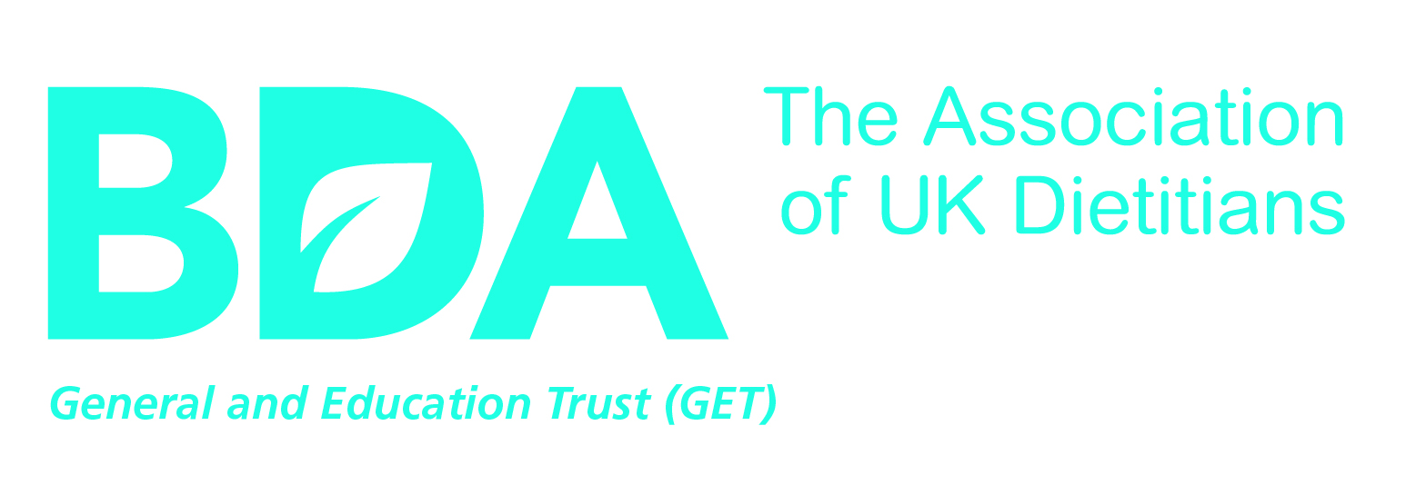

(OFFICE USE) GRANT APPLICATION NUMBER:

GRANT APPLICATION FORM
(Conference Attendance)
Name:  Address: | Telephone:  Email:
Qualifications and Professional Membership:

summary of the grant request- details of the event or conference to be attended and the applicant’s role:

Summary of What the Grant is For:

Start Date of event or conference: | Total Amount Requested:  £

1 |  | Aims and Objectives of Attendance:
 | (a) |  | Please state the aims and objectives of what you hope to achieve with the grant and by attending this event:

 | (b) | Please specify how the aims and objectives of attendance will benefit “the science and practice of dietetics”:

2 | Have you made an Application to any other Organisation for Funding to attend this conference or event? Please provide details

3 | Plans for Dissemination  Please explain how you intend to feed outputs of attendance, back into dietetics. Explain what articles, published resources, or other activities are planned.

(please continue on a separate sheet if necessary)
All recipients of GET Conference Grants but agree to acknowledge GET in their abstract, presentation or poster. Please tick to confirm that, if successful, you agree to acknowledge GET in your contribution at the Conference.
 | Yes |  | No

important:

abstracts or proposals –

support to attend any conference or event is reliant on there being a successful acceptance of an abstract or workshop proposal, or similar. THE TRUST DOES NOT FUND SUBSISTENCE COSTS.

please attach to your application a copy of the accepted abstract or proposal. no applications can be considered without this information.

Acceptance of Conditions

I have read the terms and conditions (available on the BDA website) and if my application is successful I agree to abide by them.

Signed: ______________________________________________

Date: ______________________________________________

Return application forms to:

The Secretary to the Trustees
British Dietetic Association General and Education Trust Fund
3rd Floor Interchange Place
151-165 Edmund Street
Birmingham B3 2TA
get@bda.uk.com

SCHEDULE A: DETAILS OF GRANTS REQUESTED

Expenses | Year 1  £
Cost of Travel

cost of registration at event, etc.

any other costs (please specify)

Sub total

TOTAL

