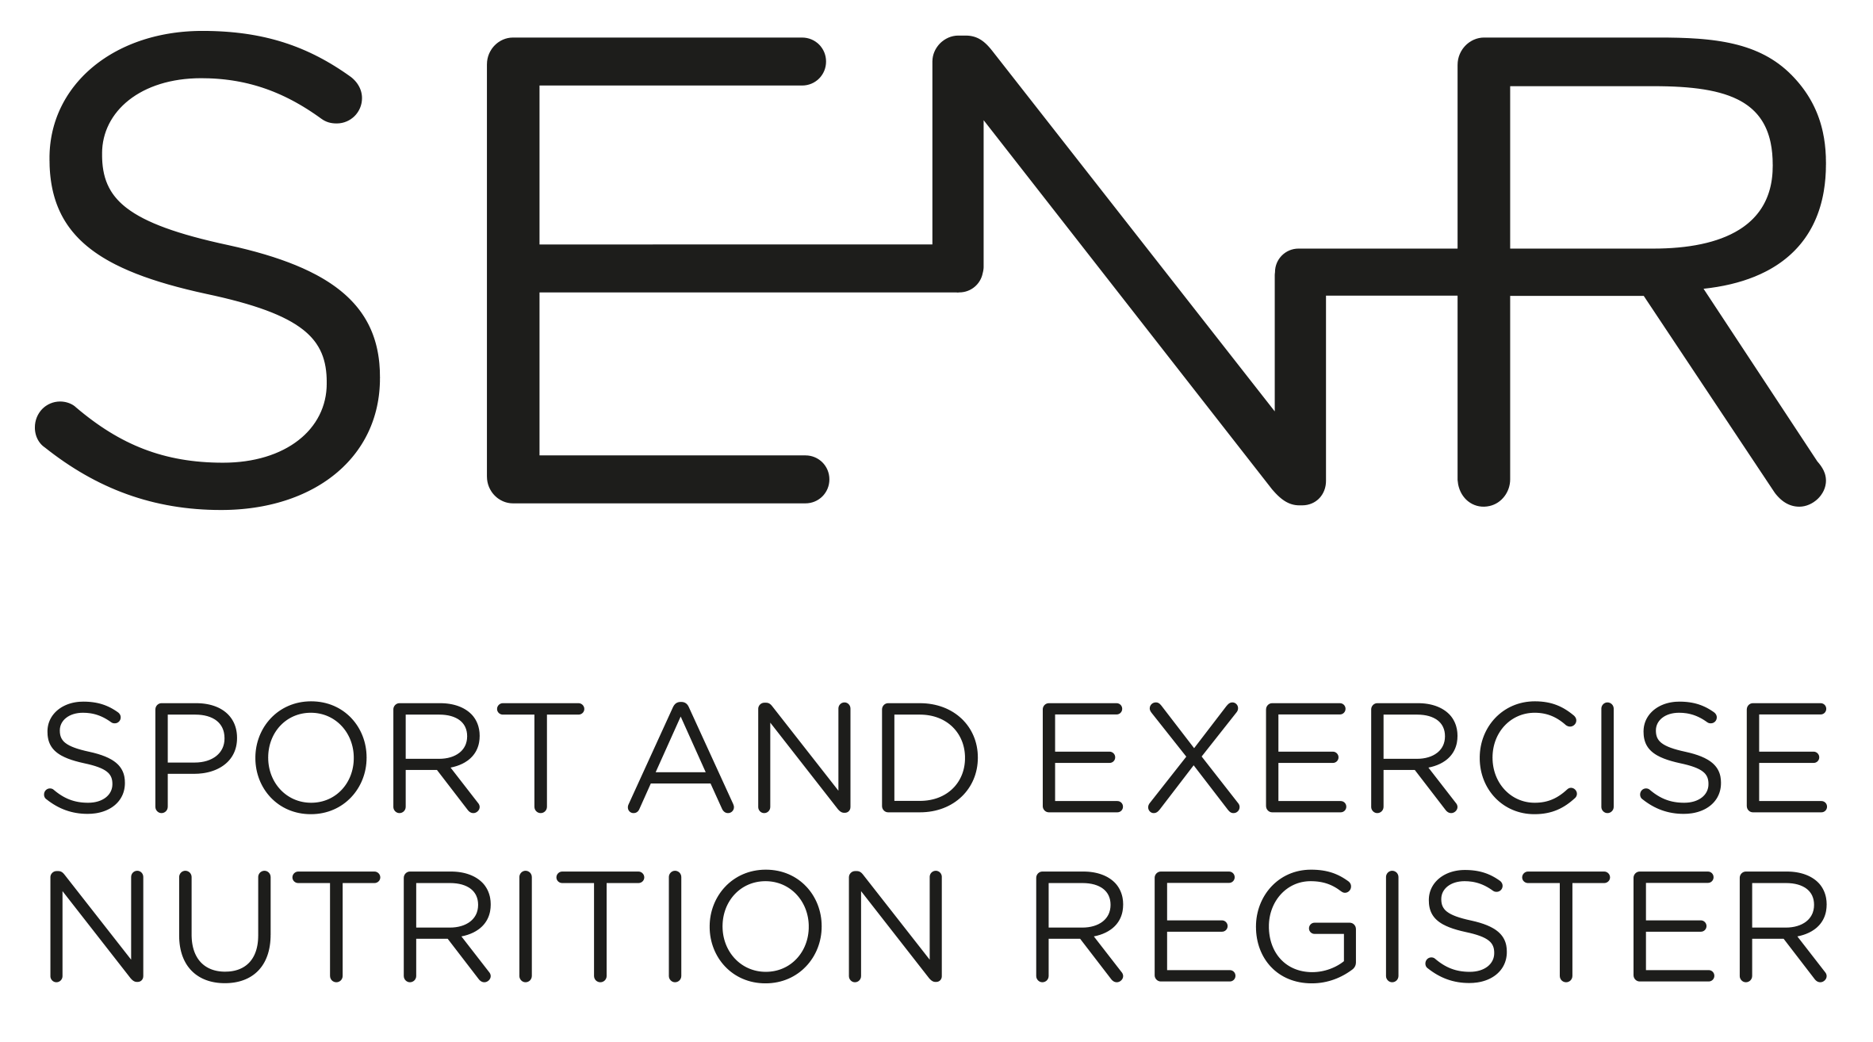

Competency Framework for the Sport and Exercise Nutrition Register (SENR)
Graduate & Practitioner

Published:
Review Date:
TBC

Competency Framework for the Sport and Exercise Nutrition Register (SENR)
Graduate & Practitioner
October 2022
Published: October 2016

Contents
Introduction 3
PART 1: Scientific Knowledge (Section A) 5
PART 2. Professional Application (Sections B - F) 10
References 19

Introduction

The key to optimal nutrition for physically active individuals, particularly the elite performer, is individualisation and personalised approaches. This encompasses assessment, education, and counselling to design, implement and evaluate nutrition strategies to enhance health and optimise performance.

Sport and exercise nutritionists enter the profession as a Graduate Registrant and develop competency through practice during their early post-registration years. They are encouraged to engage in continual professional development to advance their practice and deliver better outcomes for service users as they work towards achieving full Practitioner Registration status.

This document describes in detail the collection of competencies applicants will be expected to demonstrate in order to achieve a) Graduate Registration and b) Practitioner Registration.

All applicants (both for Graduate and Practitioner status) must meet the competency requirements in Section A, thus demonstrating robust and sound academic subject knowledge. This will be achieved through a combination of undergraduate and postgraduate study as outlined in the ‘SENR Guide to Registration’. Meeting the requirements set out in Section A will ensure an applicant’s eligibility to join the SENR Graduate Register.

Applicants applying to join the Practitioner Register must submit a portfolio of evidence to demonstrate competency in the professional application of sport and exercise nutrition. Meeting the requirements set out in Sections A-F will ensure an applicant’s eligibility to join the SENR Practitioner Register. Section F will be assessed against the case study element of the portfolio.

An overview of the SENR Competency Framework is provided in Figure 1.

Figure 1. SENR Competency Framework
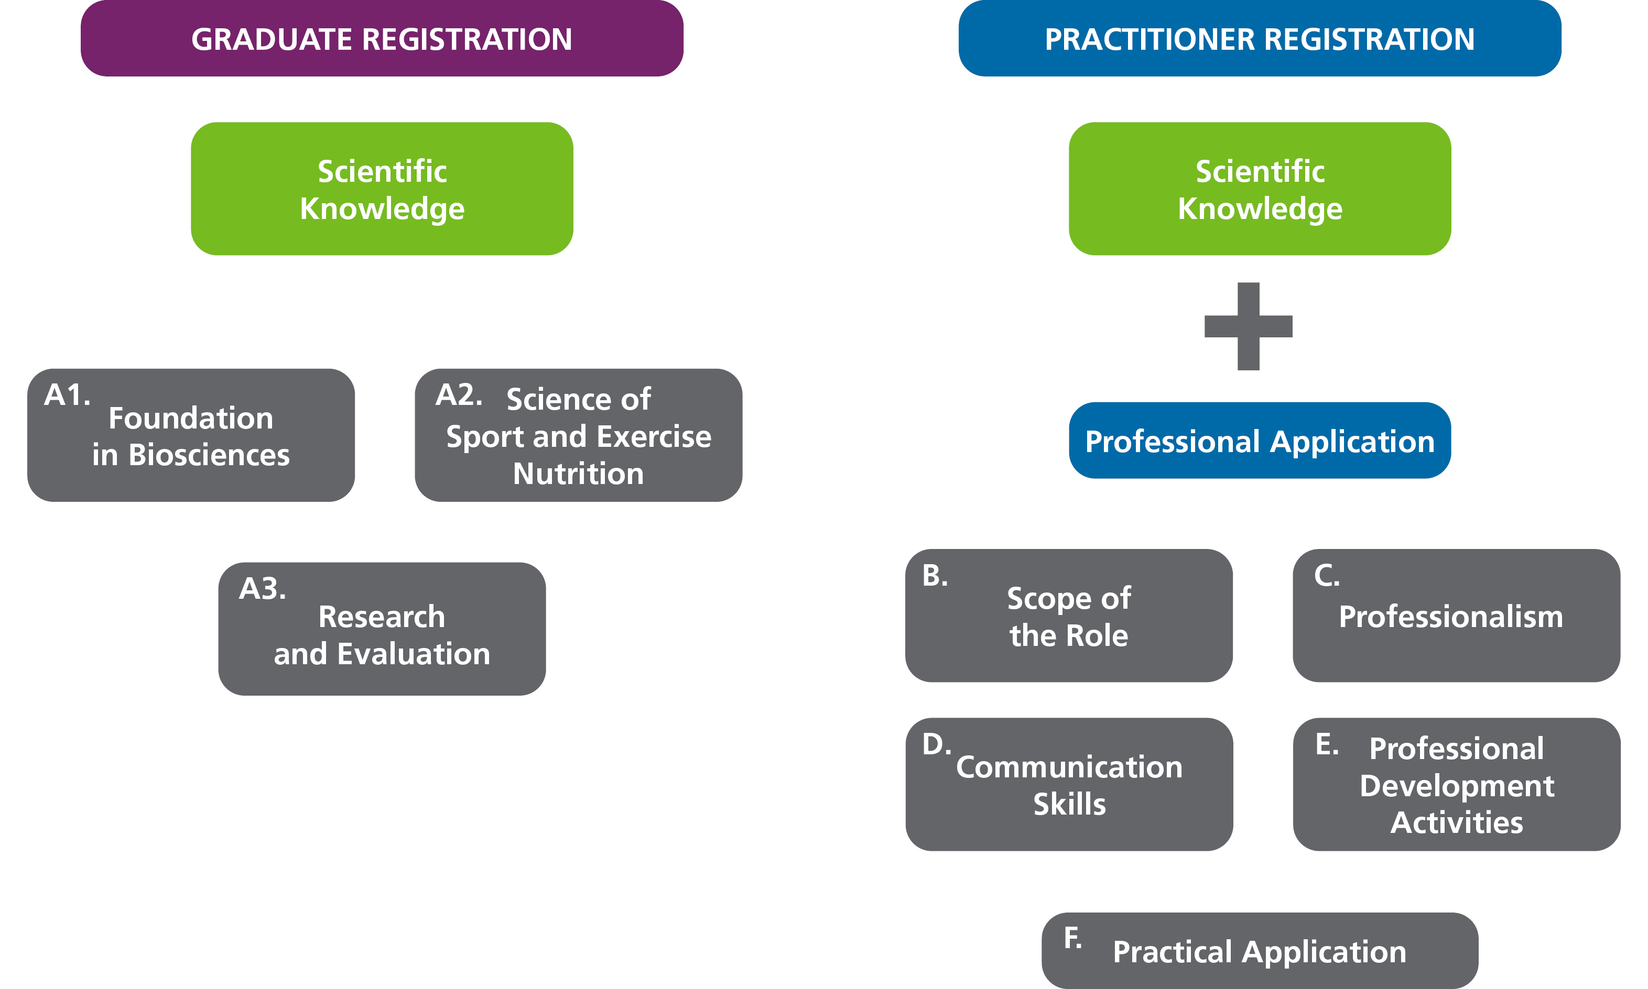

Within the Framework, competencies are categorised into two categories: Essential (E) and Desirable (D). Competencies within the Graduate Registration Framework are ALL essential. Competencies within the Practitioner Registration Framework are marked essential or desirable. With particular regard to the areas marked essential, unless otherwise stated, competency means sufficient knowledge, understanding and skill for application in safe, sound, effective and ethical practice.
Note: For some applicants a desirable competency, may be essential for the context in which you work, for example competency area C2 ‘understand the particular needs of special athlete populations (e.g., young and para-sport athletes) and tailor advice and guidance as appropriate’. If your work context includes these special athlete populations then you need to demonstrate competence in this area.

PART 1: Scientific Knowledge (Section A)

All Registrants, both at Graduate and Practitioner, must demonstrate the competencies outlined in Section A.
The Scientific Knowledge base has three components:
- Foundation in Biosciences.
- Science of Sport and Exercise Nutrition
- Research and Evaluation

NB: Registrants must demonstrate comprehensive understanding of the knowledge and skills outlined in Section A. This will be through a combination of undergraduate and postgraduate academic training in dietetics, nutrition, and sports science. Please refer to the Guide to Registration for further information. Applicants are required to submit evidence of qualifications achieved when seeking Graduate Registration.
NB: If your postgraduate qualification is via a SENR Accredited programme you only need to submit evidence of your postgraduate award.

Name of Applicant

Date of Submission

SENR Competency Assessment Form (Office Use Only)

Name of Assessor

Date of Assessment

Panel Review Date

All competencies in Section A are deemed to be Essential and must be met by all applicants.
No. | Scientific Knowledge
A1 | Foundation in Biosciences
A1.1 | Know and understand the human body and its functions, especially digestion, absorption, excretion, respiration, fluid and electrolyte balance, the cardio-vascular system, neuro-endocrine system, musculoskeletal system, immunity, and thermoregulation.
A1.2 | Know and understand mechanisms for the integration of metabolism at molecular, cellular, and whole-body levels.
A2 | Science of Sport and Exercise Nutrition
A2.1 | Basic Nutrition
A2.1.1 | Know, understand, and have the ability to critically evaluate methods of measurement and evaluation including anthropometric, dietary, biochemical, physiological and functional methods of assessment.
A2.1.2 | Know, understand, and have the ability to critically evaluate the theory and methods of investigating the dietary and nutrient patterns of the general population and subgroups of the population. This will include analysis of qualitative and quantitative dietary and nutritional data, utilising database systems as appropriate.
A2.1.3 | Know, understand, and critically evaluate nutrition science and its role in promoting human health including the:  - role of macro and micronutrients and other metabolically active components of food (e.g., fibre);  - metabolic effects of anti-nutrients (e.g., tannins), food additives, pharmacologically active agents (drugs);  - nutrient-nutrient interactions;  - potential of ‘nutraceuticals’ and functional foods;  - the nutritional composition of foods.
A2.1.4 | Know, understand, and have the ability to critically evaluate the scientific basis for the measurement and estimation of nutritional requirements, limitations and usefulness of dietary reference values and recommended dietary allowances for the general population and safe upper levels of individual nutrients including in the context of the special needs of vulnerable groups.

A2.1.5 | Know and understand the aetiology of nutritional or nutrition-related problems that are relevant to sport and exercise performance.
A2.1.6 | Know and understand how to take ethnicity or culture into account in formulating practical advice in terms of foods, meals, and menus.
A2.1.7 | Know and understand how to take dietary preferences into account in formulating practical advice in terms of foods, meals and menus (e.g., vegetarian and plant based eating).
A2.1.8 | Know and understand the principles of food preparation, handling, management, and safety.
A2.2 | Specialist Knowledge in Sport and Exercise Nutrition
A2.2.1 | Know and understand the nature of different sports to ensure an interdisciplinary approach to nutrition support to include:  - principles and components of fitness;  - physiological and biochemical demands of participation in sport and exercise;  - training practices, physical demands and rules of sports;  - lifestyles of clients;  - the nutritional implications of the physiological demands of training for and competing in sport and exercise.
A.2.2.2 | Know, understand, and critically evaluate the theoretical basis for the metabolic effects, efficacy, health, safety, and legal aspects of ergogenic aids of all kinds including pharmacologically active agents, sports foods, sports drinks, and supplements demonstrating an awareness of clean sport principles, current WADA prohibited list and practitioner responsibilities when operating in this area of practice.
A2.2.3 | Appreciate the ambitions, values, beliefs, motivations, and psychosocial concerns of clients. Know and understand contemporary models of behaviour change to underpin the development of effective interventions.
A2.3 |  | Nutrition, Health, Exercise and Sport
A2.3.1 |  | Know and understand the effects of disease processes on:  - diet and nutrition;  - exercise and sport performance.
A2.3.2 |  | Know and understand how to:  - elicit relevant information for the formulation of appropriate advice;  - select, assess, and analyse information in order to formulate recommendations about nutrient requirements and status of client(s);  - design advice that will optimise performance and give consideration to the health of the client(s);  - demonstrate a food first approach to meeting nutritional needs using appropriate and targeted supplementation where necessary;  - understand anti-doping regulations and how to advise clients regarding use of supplements and the necessity for risk mitigation protocols.
A3 |  | Research and Evaluation
A3 |  | Know, understand, and have the ability to critically evaluate a range of valid and reliable research methods appropriate to evidence-based practice in sport and exercise nutrition. Continually evaluating contemporary research to ensure own practice is evidence-based and up to date.

PART 2. Professional Application (Sections B - F)

Practitioner Registrants must demonstrate the competencies outlined in PART 2 (Sections B-F).
It is the application of the knowledge, skills and behaviours of Sport & Exercise Nutrition professionals that enables Practitioner registration with the SENR. The competencies outlined in sections B-F focus on professional application and demonstrate the registrant’s ability to practice aligned to the SENR Code of Professional Conduct.
The expectations of Practitioner registered SENR professionals are similar to those of Registered Health and Care Professionals. The Registrant is expected to demonstrate professional accountability and must recognise the scope and limits of one’s own competence. Thus, the registrant must refer and defer to other professionals for advice and guidance as appropriate. In the context of sport and exercise nutrition this is most likely to be required for complex clinical conditions.
The competencies are identified as being either Essential (E) or Desirable (D), with particular regard to the Essential category, defining as it does the minimum standards indicating adequate preparation for safe, ethical practice in the profession.
Note: for some applicants a desirable competency, may be essential for the context in which you work, for example competency area C2, understand the particular needs of special athlete populations (e.g., young and para-sport athletes) and tailor advice and guidance as appropriate. It is the registrant’s responsibility to evidence this where appropriate.

No. | Competency Area | Essential or  Desirable | Applicants should use this area to signpost the evidence within their portfolio that demonstrates their ability to meet each competency area. Please provide additional information where relevant in the applicant commentary sections at the end of each competency area section.
 |  |  |  | Competence Assessment (for Assessor use)
 |  |  |  | Met Fully | Partially  met | Not met
B | Scope of the role
B1 | Boundaries of the Profession
B1.1 | Maintain fitness to practice, ensuring ongoing adherence to the SENR Code of Conduct². | E
B1.2 | Know your limit of practice and when and where to refer to another professional, for example clients with complex health issues. | E
B1: Applicant Commentary
B1: Assessor Comments

B2 | Legal and Ethical Framework  - Legislation  - Protecting Client(s), Self, Colleagues, Organisation
B2.1 | Understand and apply the legal and ethical responsibilities of professional practice³, exercising a duty of care to clients including adherence to child protection and vulnerable adults safeguarding legislation or policies. | E
B2.2 | Be familiar with and comply with anti-doping practices, procedures, and legislation. Providing current evidence of anti-doping advisor training. | E
B2.3 | Maintain appropriately detailed records of client care, as detailed in the SENR Record Keeping Guidance⁴ document. | E
B2.4 | Adhere to the principles of GDPR in sharing of information⁵. | E
B2.5 | Acknowledge equality, diversity, and inclusion in the rights of the individual and ensure that practice serves the best interests of client(s). | E
B2.6 | Maintain safe working that conforms to health and safety legislation and organisational policies⁶. | E
B2.7 | Obtain informed consent before any intervention or sharing of information. | E
B2: Applicant Commentary

B2: Assessor Comments

C | Professionalism  - Practicing as an Autonomous Professional  - Teamworking
C1 | Work collaboratively to plan, implement and review interventions with the client, team and/or other stakeholders. | E
C2 | Understand the particular needs of special athlete populations (e.g., young and para-sport athletes) and tailor advice and guidance as appropriate. | D
C3 | Contribute as appropriate to the formulation of standards, guidelines, strategy, and policy on behalf of your organisation or sporting or regulatory body. | D
C4 | Be familiar with and apply current policy relating to health, exercise and sport including the relevant policies and procedures of governing bodies, institutes of sport, sport councils and Olympic and Paralympic Associations. | E
C: Applicant Commentary

C: Assessor Comments

D | Communication Skills
D1 | Demonstrate proficient communication skills to elicit, interpret, integrate, assess, and apply relevant information in order to provide safe and sound individualised advice⁷. | E
D2 | Present information clearly, tailored to the needs of the client or audience, where groups are concerned, promoting sport and exercise nutrition in an informative, engaging, and professional manner. | E
D3 | Collate, analyse and interpret information on behalf of client(s), developing resources to support service interventions and client education. | E
D: Applicant Commentary

D: Assessor Comments

E | Professional Development Activities
E1 | Demonstrate reflective practice to evaluate and inform practice development. | E
E2 | Be proactive in, and take responsibility for, developing and improving own competence including maintaining a personal development portfolio which identifies learning and development needs, plans, actions, and outcomes. | E
E: Applicant Commentary

E: Assessor Comments

F | Practical Application  (Note: competency areas identified in section F must be demonstrated by the case study)
F1 | The Needs of the Client(s)
F1.1 | Interpret nutritional assessment information including dietary evaluation, anthropometric assessment, biochemical analysis, clinical observation, environmental, functional, and behavioural assessment to plan nutritional intervention. | E
F1.2 | Taking account of the phase of training, competition, travel and environmental conditions, translate nutrient and energy requirements into an appropriate and tailored, evidence-based nutritional programme to support client(s). | E
F1.3 | Apply appropriate and contemporary theories of behaviour change, counselling, and communication in order to initiate and sustain changes in dietary behaviour addressing barriers to successful implementation, such as food availability, cooking skills, financial concerns etc. | E
F1.4 | Monitor and evaluate interventions over time implementing appropriate outcome measures and adjusting the nutrition strategy as appropriate. | E
F2 | Understanding and Supporting the Sport and Exercise Environment
F2.1 | Appreciate the athlete lifestyle and role of significant others. In providing nutritional advice and intervention. | E
F2.2 | Demonstrate ability to problem solve in an interdisciplinary way with practitioners from other disciplines, for example, coaching staff or sports medicine team. | E
F2.3 | Assess the performance impact (positive or negative) of nutritional intervention and challenge current practices by engaging with research and innovative practice. | E
F: Applicant Commentary

F: Assessor Comments

Assessor Overall Comments

Is the applicant suitable to register as an SENR Practitioner Registrant?
If no, please state reasons and any advice for re-submission.
Please note these comments will be fed back to the applicant.

Signed
Date

This Competency Framework for Sport and Exercise Nutrition is a dynamic document. Just as a SEN practitioner’s continuing professional development and self-evaluation is an ongoing cycle, this Competency Framework is also subject to regular evaluation and review. Current and future initiatives of the SENR and advances in sport and exercise nutrition practice and research will continue to inform the development of this Framework that aims to set, maintain, and enhance professional and ethical standards in Sport and Exercise Nutrition.

References

British Dietetic Association (BDA): SENR Guide to Registration¹. BDA, 2022
British Dietetic Association (BDA): SENR Code of Professional Conduct². BDA, 2021
Health and Care Professions Council (HCPC): Standards of Conduct, Performance and Ethics³. HCPC, London, 2016

British Dietetic Association (BDA): SENR Record Keeping Guidance⁴. BDA, 2021
HM Government: Data Protection Act 2018⁵. HM Government, London, 2018

Health and Safety Executive (HSE): Health and Safety Regulation - a short guide⁶. HSE, London, 2013

Health and Care Professions Council (HCPC): Certificate of English Language Proficiency⁷. HCPC, London, 2022

