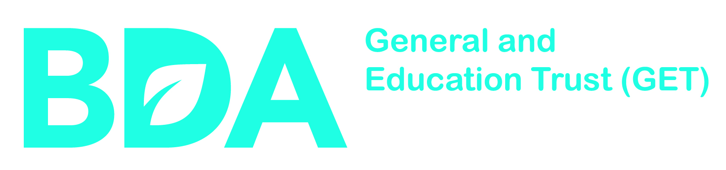

BRITISH DIETETIC ASSOCIATION
GENERAL AND EDUCATION TRUST
End of grant – FINAL report form

RATIONALE

As you know from the Terms and Conditions and Administrative Guidelines for Grants, all grant holders are required to submit a report at the end of their period of funding. The End of Grant Final Report Form is an opportunity for you to share details of the achievements and implications of the project or research that the British Dietetic Association General & Education Trust has supported. The information contained in the report is of great value as it allows us to assess and review the outputs and outcomes of the research that we fund. This critical information enables the BDA GET to ensure that the project or research has been carried out in accordance with our charitable objectives and is a vital input to future planning and strategy setting.

COMPLETING THE FORM

We would be grateful if you could complete this form electronically in Word, save it and return it as an e-mail attachment to: GET@bda.uk.com

- To insert text in the answer fields, simply left-click in the grey areas and type. The answer grids will extend automatically as you type.
- To select check boxes, left-click in the box. Left-clicking the box a second time will deselect that option. The space bar will also select and deselect check box options.
- In addition, the tab and shift + tab keys can be used to move between answer fields and the space bar to delete highlighted text.

You are asked to record key research achievements, implications and outputs. This section of the form may be sent to external assessors for comments.

CONDITIONS

The End of Grant Final Report Form must be submitted within three months of the grant end date. Failure to submit a report may cause the final payment to be delayed, and / or may cause the BDA GET to refuse to consider further grant requests.

The End of Grant Final Report Form may be presented as an annex to any future applications you make to the BDA GET.

10% of the project funding will be retained until satisfactory completion of this report form.

CONTACT US

If you have any general questions or comments about the completion of this form then please email us at: GET@bda.uk.com

BDA GET Grant Number

Name of Grant Holder

Project Title

OVERVIEW

What was the overall aim of the work supported by this grant? (no more than 150 words)
What have you discovered / achieved? (no more than 350 words)
What are the implications of this work? Please include details of anticipated outputs and outcomes,
policy implications and changes in healthcare practice, with timelines. (no more than 350 words)

Please provide a lay summary of the discoveries, achievements and implications of this work (if this has not been provided above in lay terms). (no more than 350 words)
Please note that we may wish to extract this text for publication on our website or release it into the public
domain.

Have any other funding bodies been involved in supporting the development of the  work supported by this grant? If yes, please give details (no more than 150 words) | Yes No

Grant Holders must declare whether any of the activity has resulted in income  generation? If yes, please give details (no more than 150 words) | Yes No

Did the grant terminate prematurely? If yes, please explain why (no more than 150 words) | Yes | No

DISSEMINATION

Please provide details of how the results of the work supported by this grant have been disseminated to both
the scientific and wider community.

Research Publications
(a) Please tell us how many accepted (in press/published) original peer-reviewed publications (research papers/books/monographs) have resulted directly from your work supported by this grant to date.
 | Research papers | Books/Monographs
Total number of publications

(b) Please provide details of all accepted research papers, books or monographs (either published or in press) associated with your award (boxes will expand on entry).

(i) Article publications
Use the box below to provide details of papers supported by this grant.
Under this option, please detail in the following order: Author(s); Article Title; Journal Name; Year; Volume; Issue Number; Page Numbers; PubMed ID or PubMed Central ID – please indicate what ID number has been provided by prefixing the number with either PMID or PMCID.

(ii) Article publications – in press
Please detail in the following order; Author(s); Article Title; Journal Name; Year; Volume; Issue Number; Page Numbers.

(iii) Book and monograph publications (published and in press)
Please provide details of all books/monographs that have arisen as a result of this award. Please indicate whether the book or monograph has been published or is still in press.

Please detail in the following order: Author(s); Title; Publisher; Publication Year.

Research resources/Intellectual property

Please tell us if any research resources development/intellectual property activity has resulted directly
from the research funded through this grant to date. Please tick those that apply.
Software/database development
Patents filed
Product licenses
Other
Please tell us in more detail about any intellectual property activity or research resources developed,
and briefly summarise how the data or resource resulting from the research was managed and shared
with other researchers. (no more than 350 words)

Communication/public engagement activities

Please tell us if you have carried out any communication/public engagement activities with the research/research outcomes associated with this grant to date. Please tick those that apply.
Academic workshop/conference presentations
Dietetic profession feedback
Presentations to non-academic audiences (including schools)
Feedback to research participants and related communities
Meetings or discussions with policy makers/healthcare professionals
Media coverage
Other
Please tell us in more detail about these communication/public engagement activities. (no more than 250 words)

Collaborations

Please tell us if research supported by this grant to date has resulted in any of the following types of collaboration. Please tick those that apply.
Collaborations with commercial partners
Collaborations with academic groups outside of this award
Other
Please tell us in more detail about these collaborations. (no more than 250 words)

Please summarise the number of staff, in the categories set out below, who were in receipt of a salary or stipend from this grant (including yourself).

Job title of staff | Full-time | Temporary/ part-time
Academic Staff
Clinical/Healthcare (non dietitian)
PhD Students / post-graduates or equivalent
Dietetic Staff
Other research staff (e.g. social scientists, statisticians, health economists, epidemiologists)
Other Administrative & Support Staff

How has the grant contributed to the professional development of the staff named above (including yourself)? (no more than 250 words)

Please give details of how this grant has contributed to any training that has been provided to others
(e.g. dietitians or other healthcare professionals). (no more than 250 words)

Please tell us if you, or any of the staff described above, have received any prizes, awards or commendations, as a direct result of the research supported by this grant to date. Please give details, including the name of the recipient, below.

ADDITIONAL FEEDBACK

Do you have any comments you would like to make regarding this BDA GET grant, the conduct of this research, or any difficulties you have encountered?

Thank you for taking the time to complete this form. Please email your completed form to GET@bda.uk.com

